Julian Burgoff

11/8/2022

Analysis of Environmental Data

Using Models 1

1. 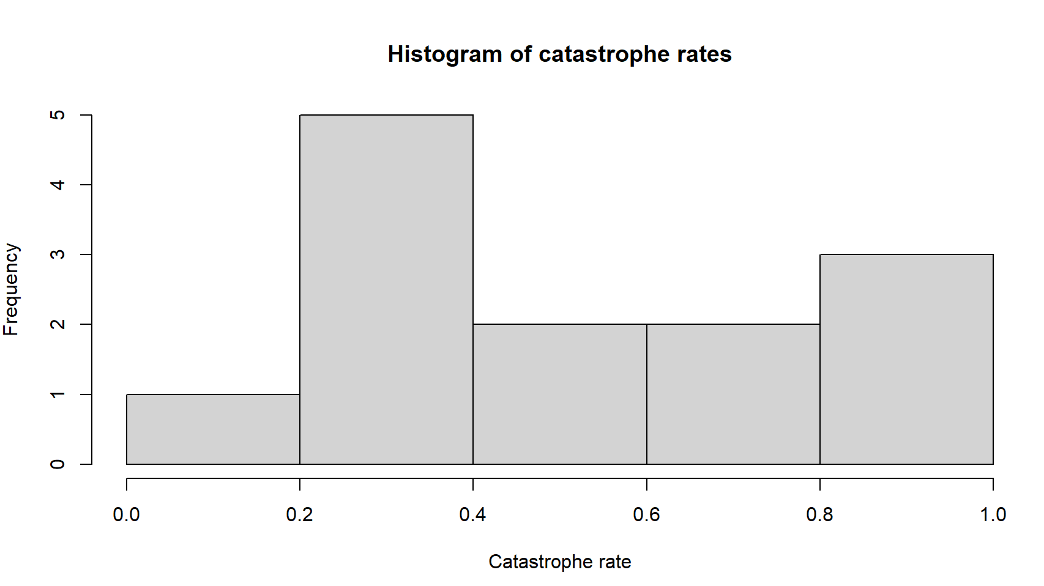
2. shapiro.test(catrate$cat.rate)

p-value = 0.04097

1. The null hypothesis is that the data were sampled from a normally distributed population
2. The p value is low which suggests good evidence against the null hypothesis, which means that there is strong evidence that the sample came from a non-normally distributed population.
3. t.test(catrate$cat.rate, mu= 0.28)
4. The null hypothesis is that the mean of the population from which the data were collected is not different from x.
5. This is a two tailed test
6. p-value = 0.01054. This low p value suggests that the catastrophic rate is significantly different from the pond late-filling rate.

95 percent confidence interval:

0.3526250 0.7261295

1. We can safely reject the null hypothesis that there is no difference between the catastrophic rate and the pond late-filling rate because the p value is much lower than 0.05.
2. wilcox.test(catrate$cat.rate, mu = 2 / 7)
3. p-value = 0.006275 smaller p value than the t test
4. There is strong evidence to reject the null hypothesis given the very small p value (0.006) produced from the rank sum test.
5. The two tests led to the same conclusion to reject the null hypothesis, but considering the shape 15. of the histogram I would say the rank sum test would be better because the data do not look normally distributed.
6. # Extract the Adelie penguin data

dat_adelie = subset(penguin_dat, species == "Adelie")

shapiro.test(dat_adelie$flipper_length_mm)

dat_chinstrap= subset(penguin_dat, species== "Chinstrap")

shapiro.test(dat_chinstrap$flipper_length_mm)

1. Shapiro-Wilk normality test

data: dat_adelie$flipper_length_mm

W = 0.99339, p-value = 0.72

Shapiro-Wilk normality test

data: dat_chinstrap$flipper_length_mm

W = 0.98891, p-value = 0.8106

Both tests produced p values that were far greater than 0.05, which suggests that the flipper length data for both species of penguins is normally distributed.

1. 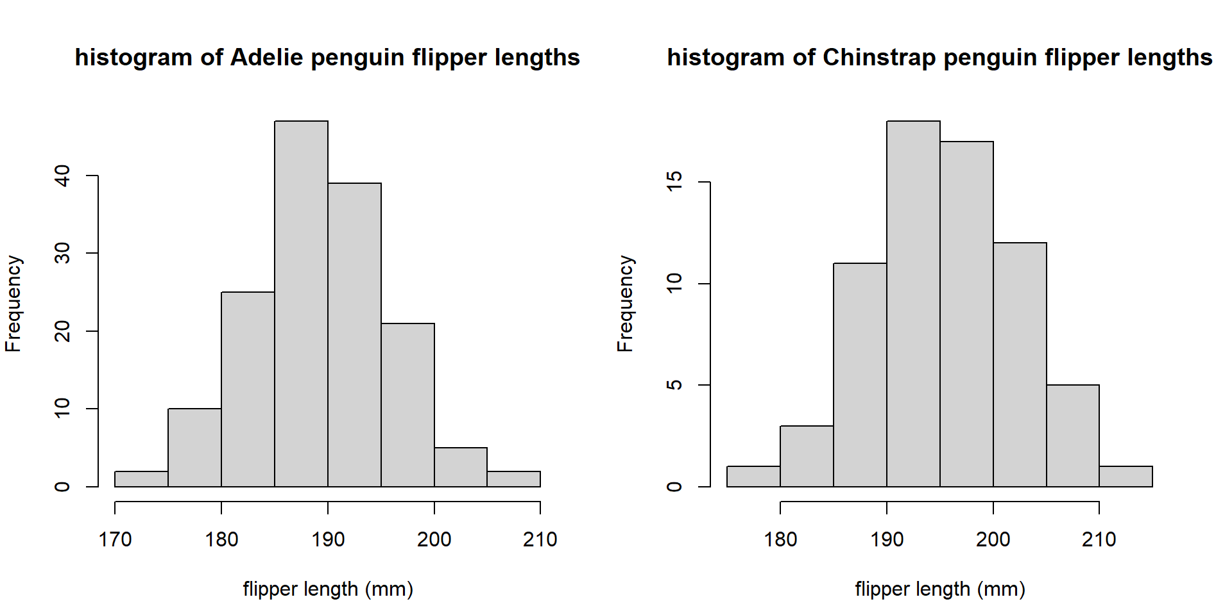
2. The alternative hypothesis is that chinstrap and adelie penguins have significantly different flipper lengths.
3. t.test(flipper_length_mm ~ species, data = penguin_dat)